IDB Lab -3

1.Select ename, job, deptno from emp where job= ‘CLERK’;

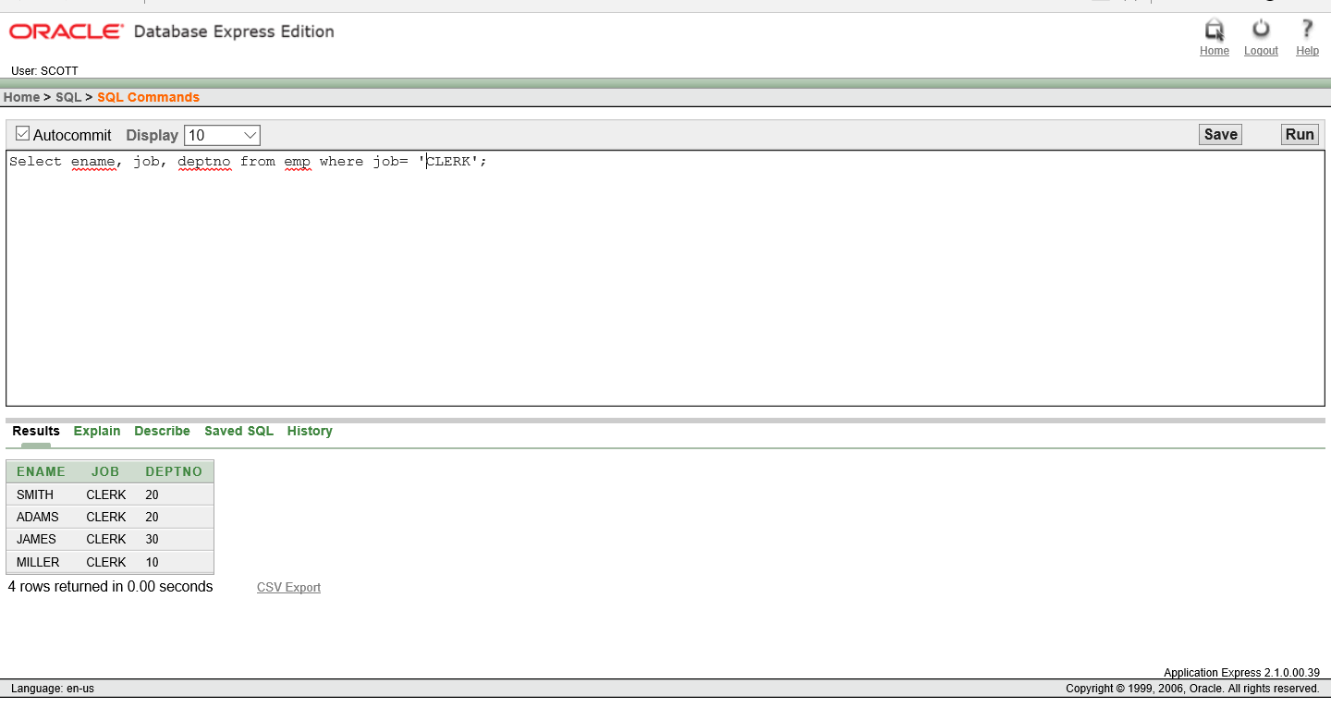

2. Select ename, job, deptno from emp Where ename = ‘ JAMES’;

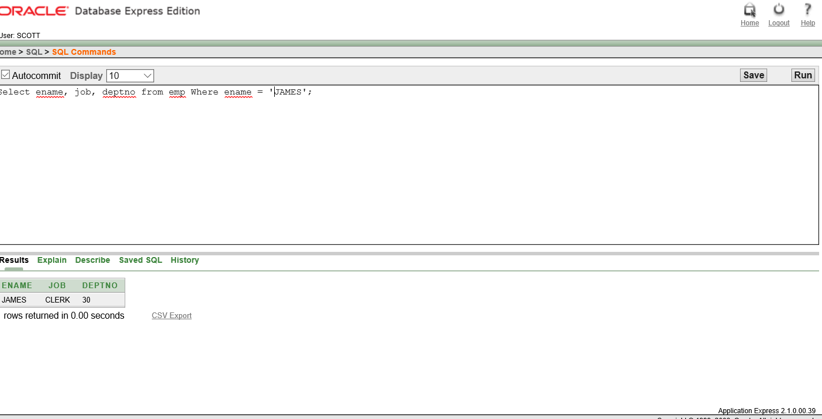

3.Select ename, sal, comm from emp where sal<=comm;

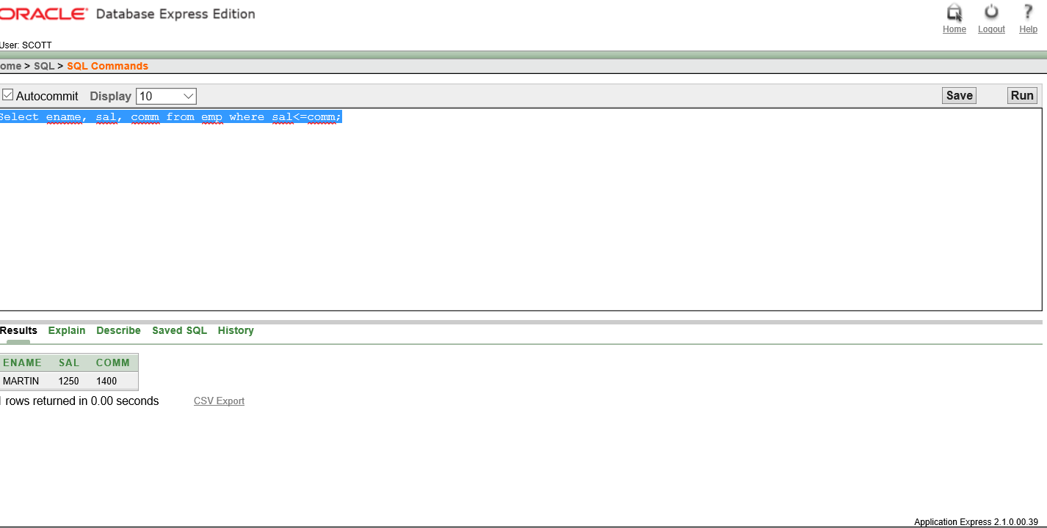

4. Select ename, sal from emp Where sal BETWEEN 1000 AND 1500;

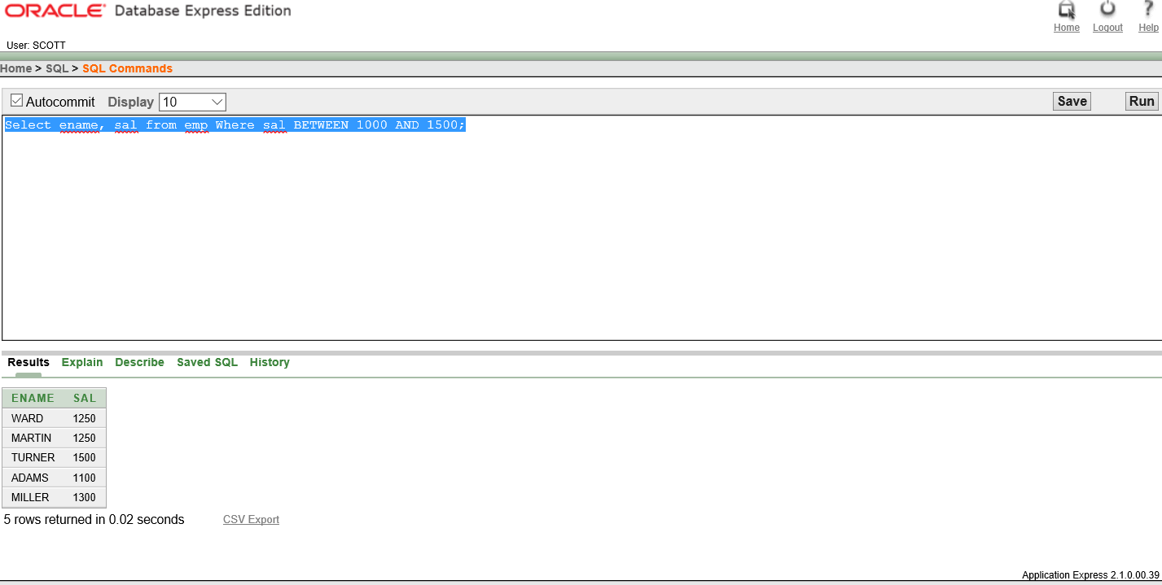

5. Select empno, ename, sal , mgr from emp where mgr IN (7902, 7566, 7788);

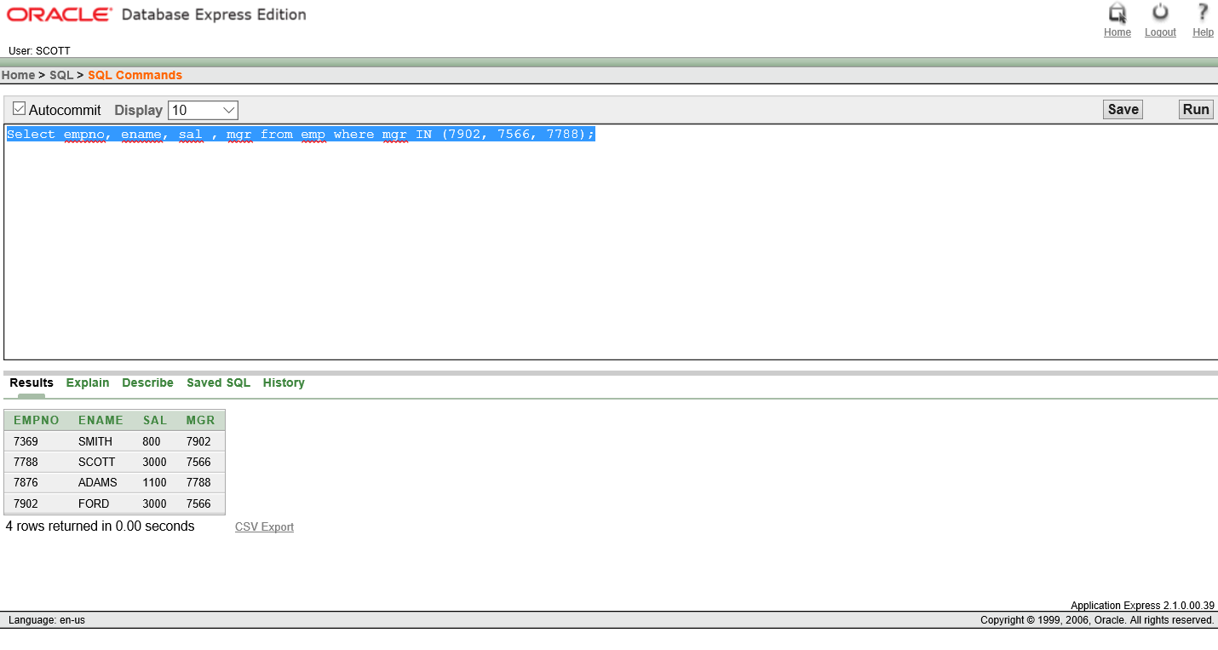

6. Select ename from emp where ename LIKE ‘S%’;

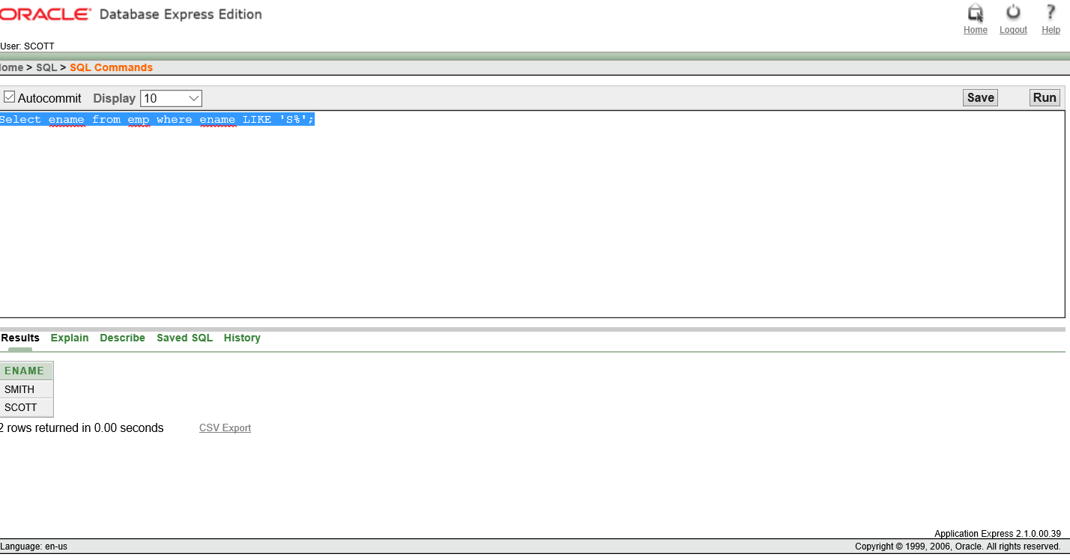

7. Select ename from emp Where ename LIKE ’A%’;

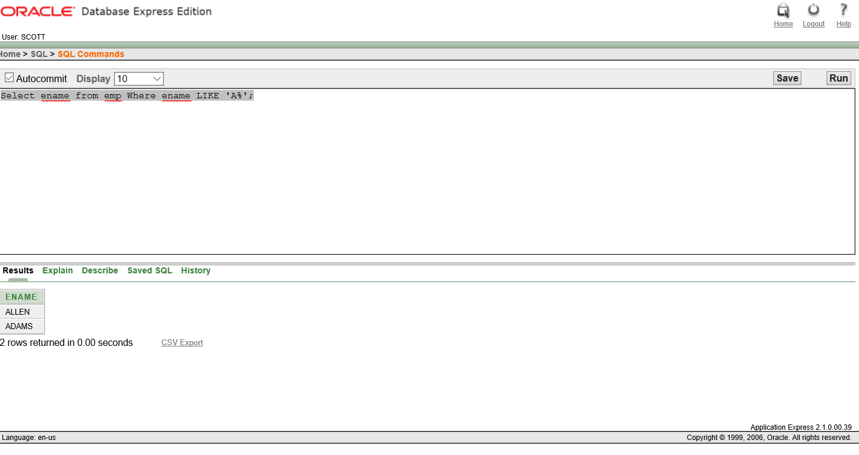

8. Select ename, mgr from emp where mgr is NULL;

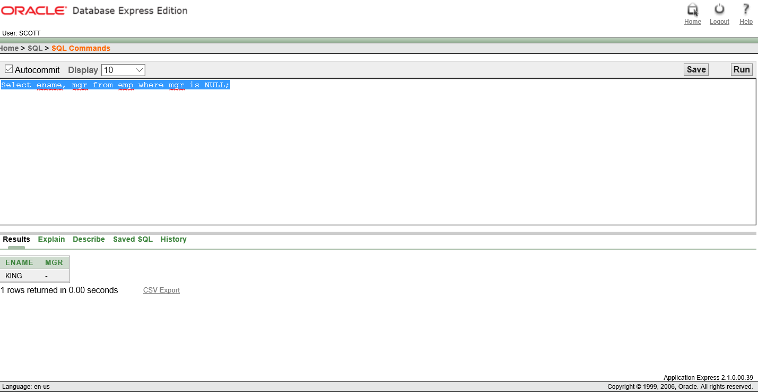

9. Select empno, ename, job, sal from emp Where sal>=1000 And job=’CLERK’;

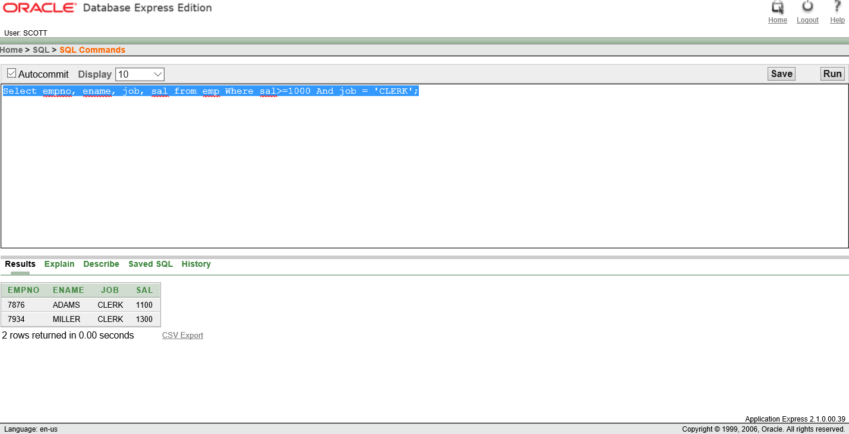

10.Select empno, ename, job, sal from emp Where sal>=1100 Or job = ‘CLERK’;

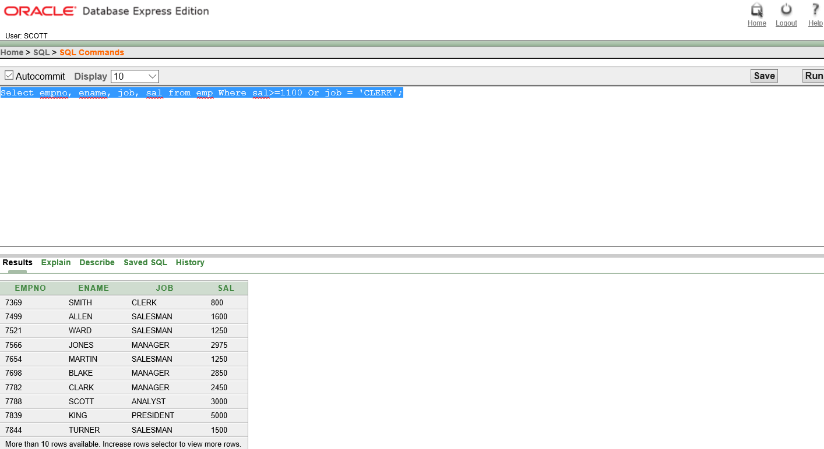

11. Select ename, job from emp where job NOT IN (‘CLERK’, ‘MANAGER’, ‘ANALYSIS’);

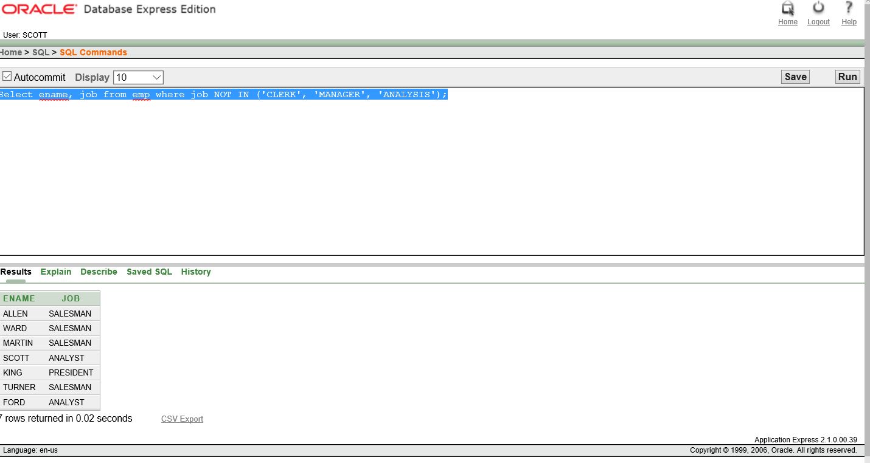

12. Select ename, job, sal from emp Where (job= ‘SALESMAN’) OR job=’PRESIDENT’ AND sal>1500;

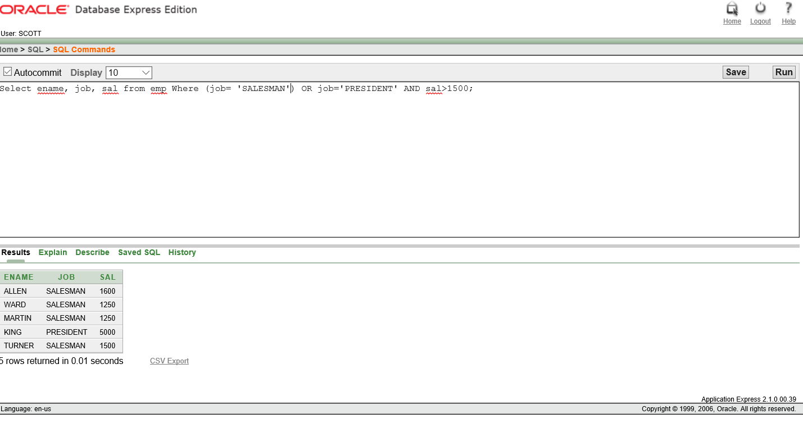

13.Select ename, job , sal from emp where job=’SALSMAN’ OR job=’PRESIDENT’ AND sal>1500;

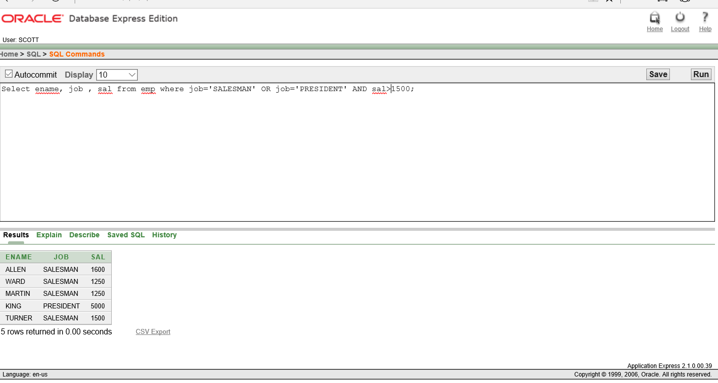

14.Select ename, job, deptno , hiredate from emp ORDER BY hiredate;

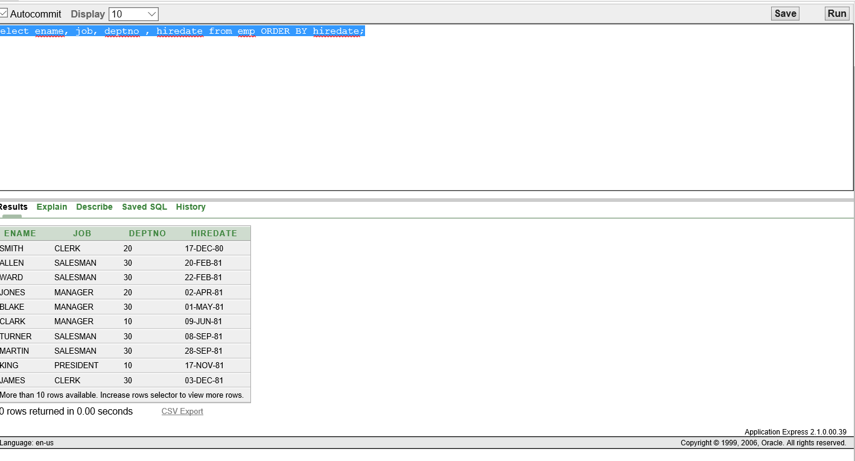

15. Select ename, job, deptno , hiredate from emp ORDER BY hiredate DESC;

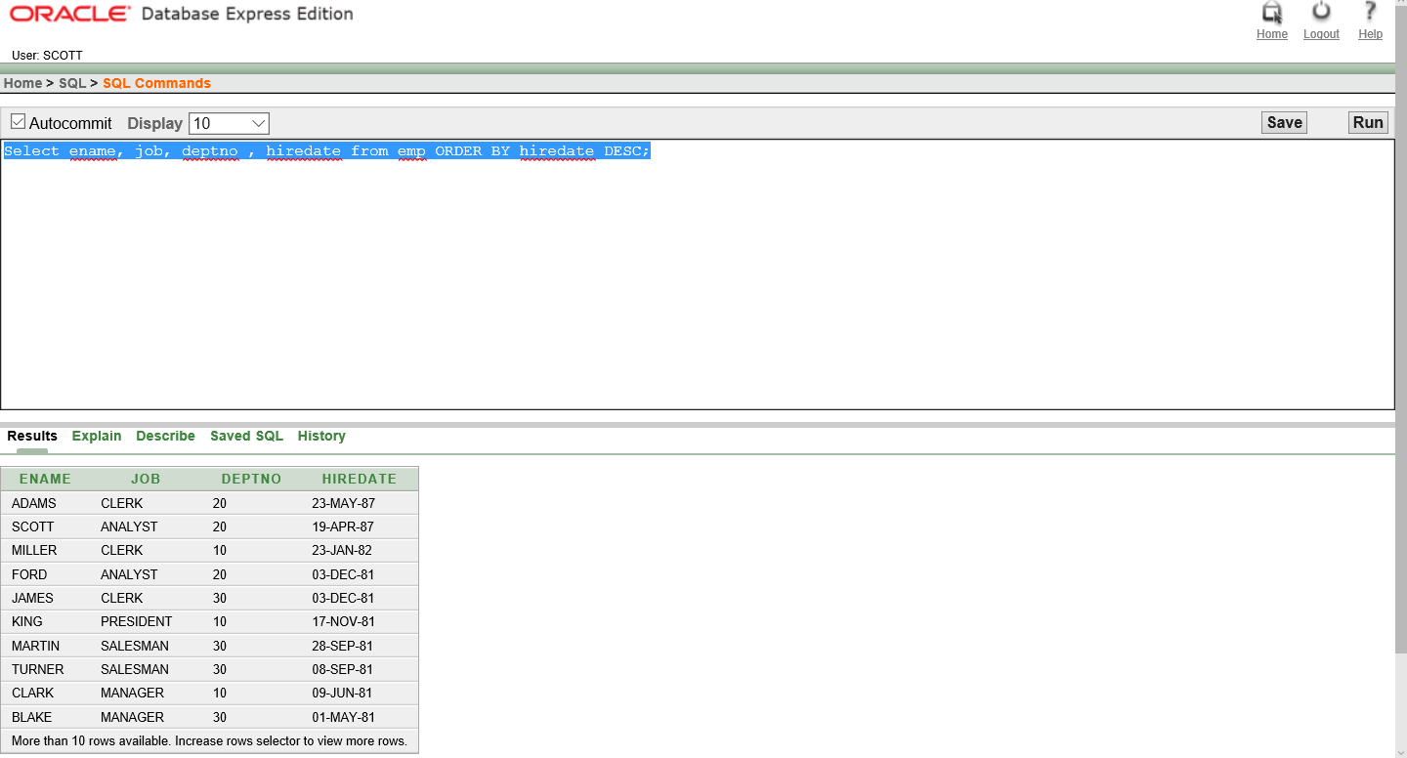

16. Select empno, ename, sal*12 annsal from emp ORDER BY annsal;

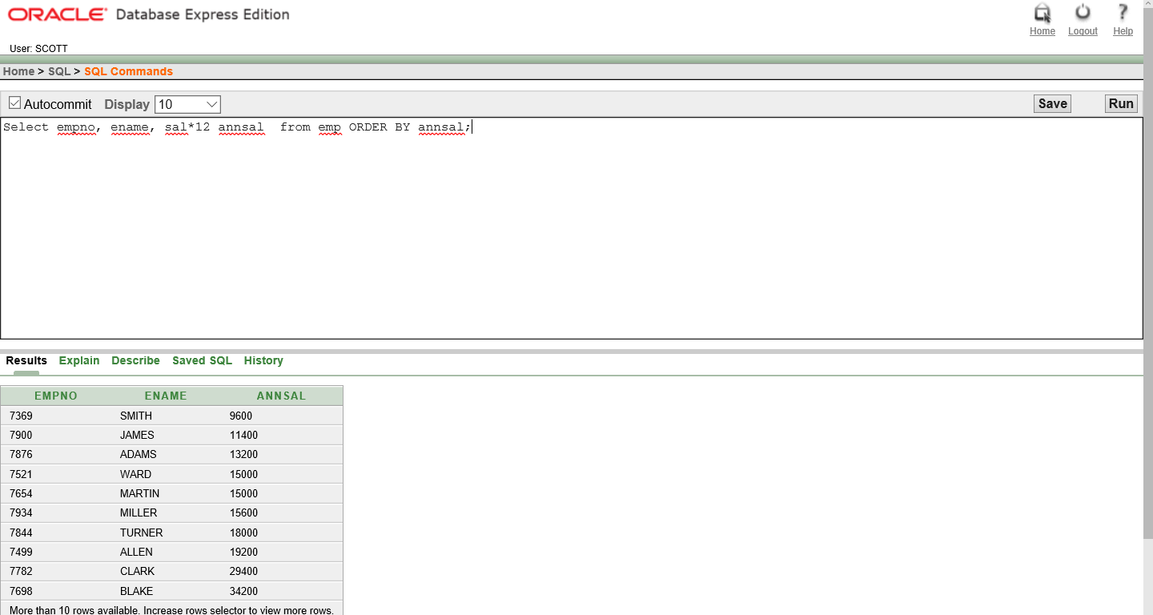

17.Select ename, deptno, sal from emp ORDER BY deptno, sal DESC;

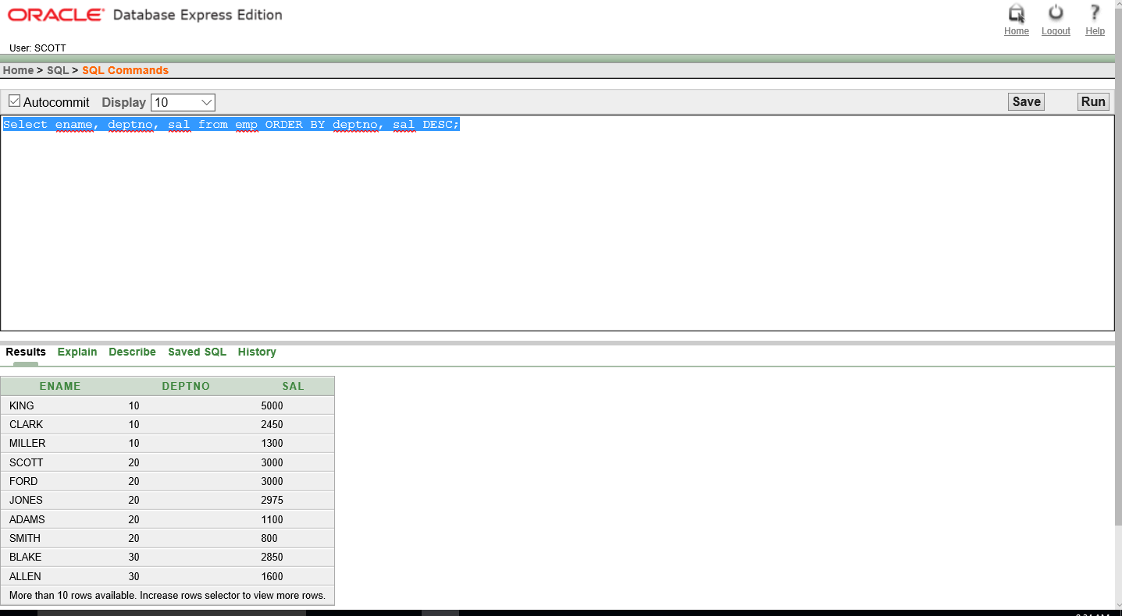

18.Select empno, ename,deptno FROM emp Where ename = ‘blake’;

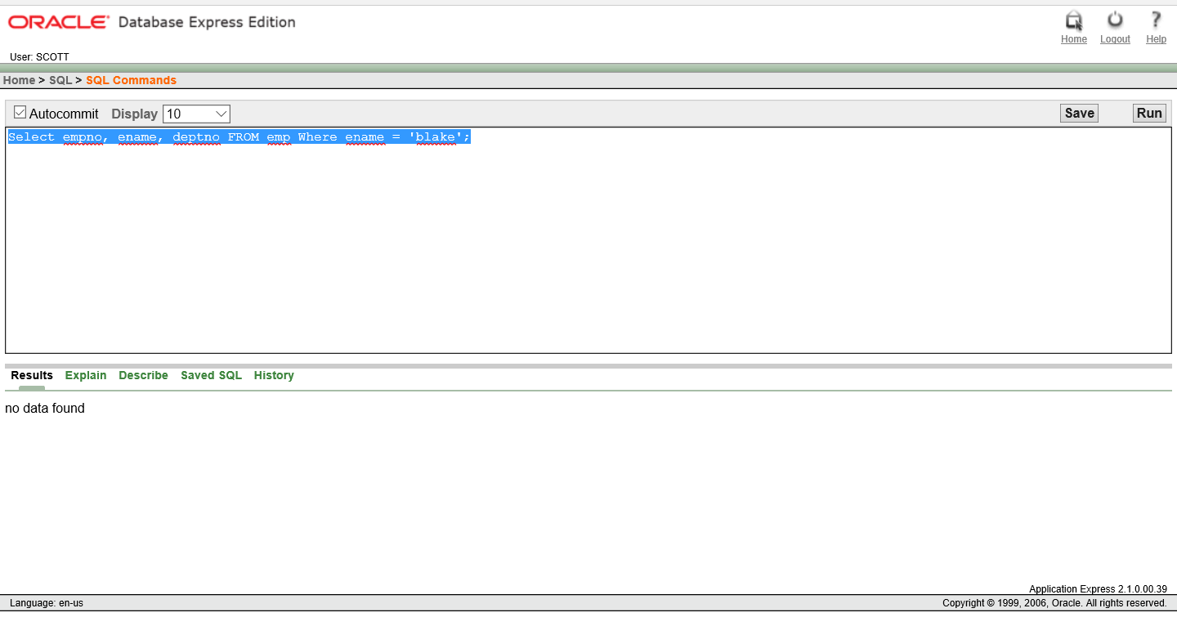

19. Select empno, ename,deptno FROM emp Where LOWER(ename) = ‘blake’;

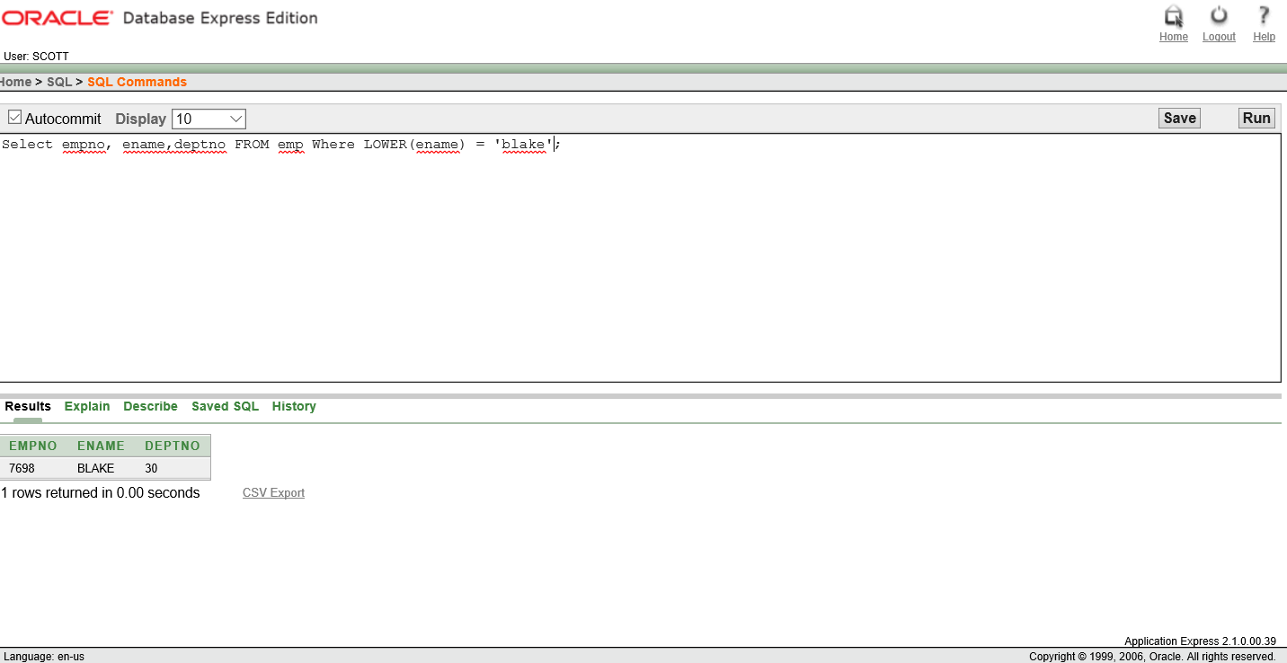

20. Select ename, CONCAT (ename,job) , LENGTH(ename), INSTR(ename, ‘A’) from emp Where SUBSTR(job, 1,5)= ‘SALES’;

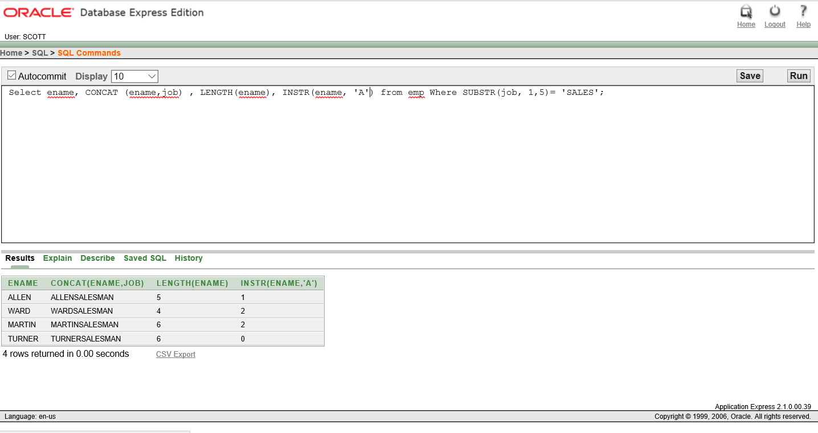

21. Select ROUND(45.923, 2), ROUND(45.923), ROUND(45.923, -1) From DUAL;

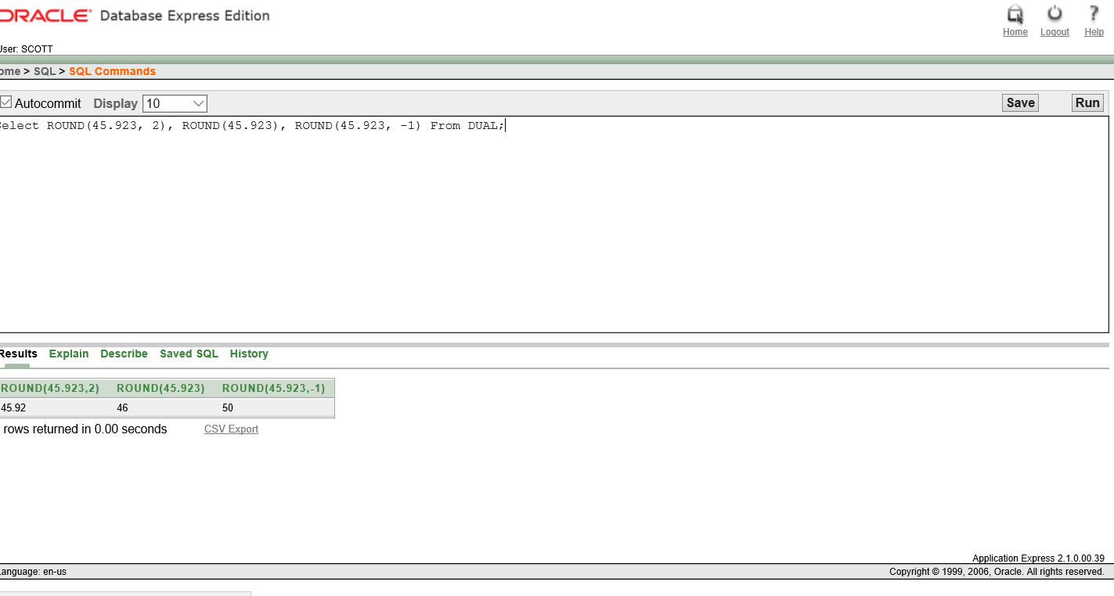

22.Select TRUNC(45.923,2), TRUNC(45.923), TRUNC(45.923, -1) From DUAL;

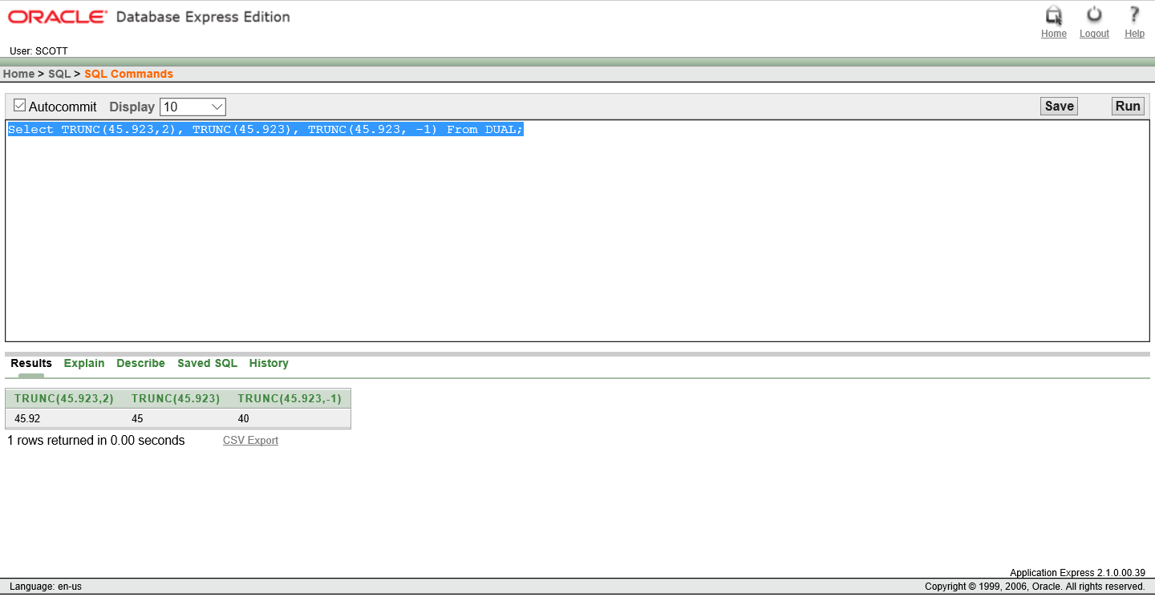

23. Select ename, sal, comm, MOD(sal, comm) From emp WHERE job=’SALESMAN’;

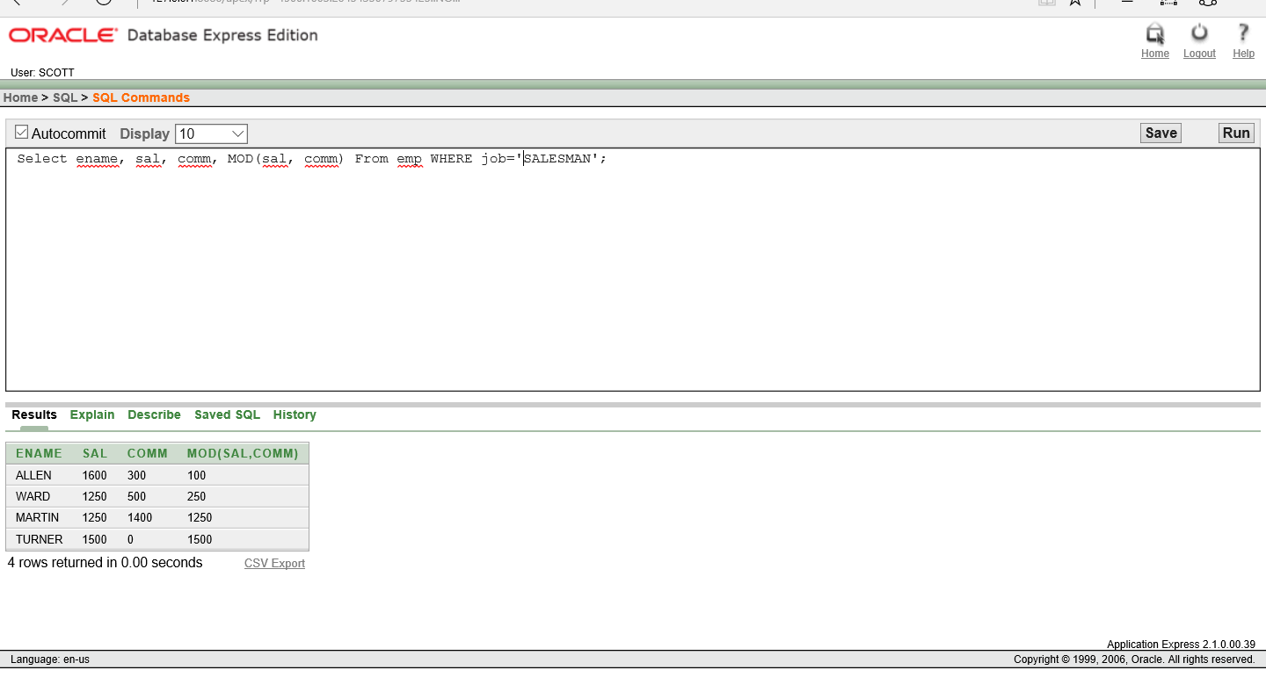

24. SELECT ename, TO_CHAR(hiredate, 'fmDD Month YYYY') HIREDATE FROM emp;

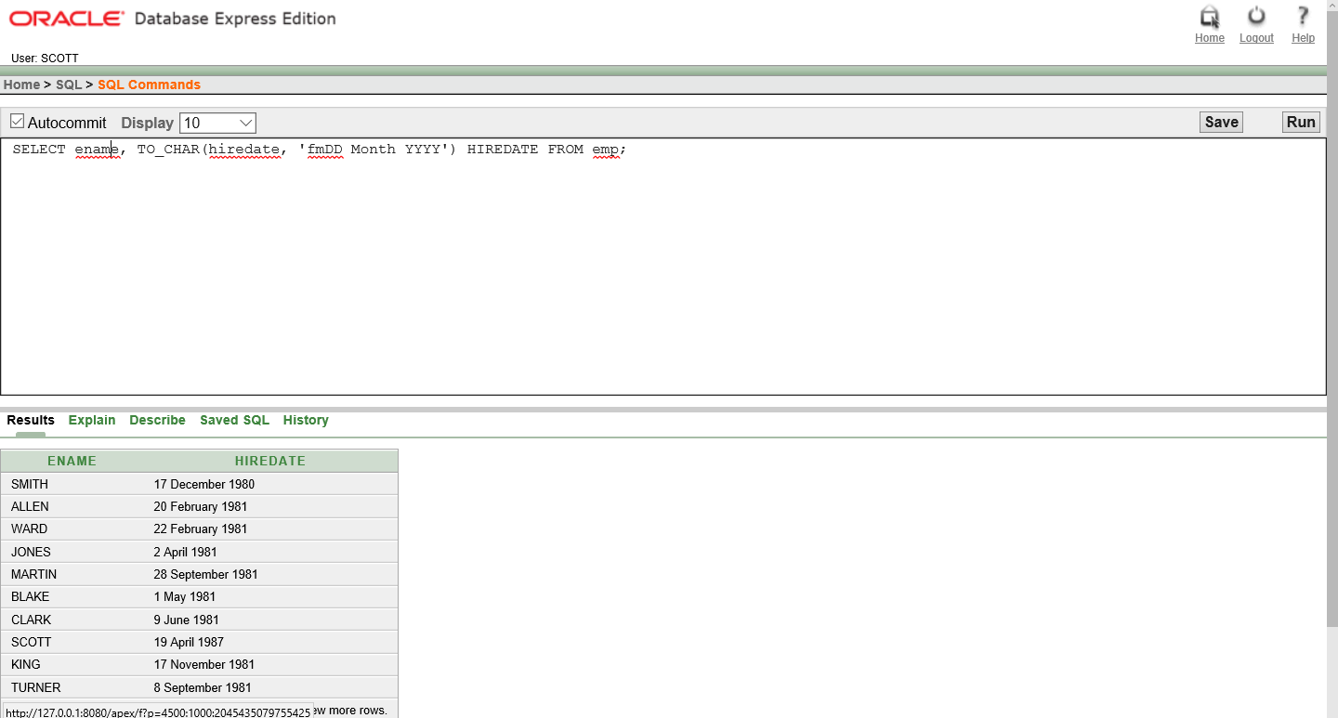

25. SELECT TO_CHAR(sal,'$99,999') SALARY FROM emp WHERE ename = 'SCOTT';

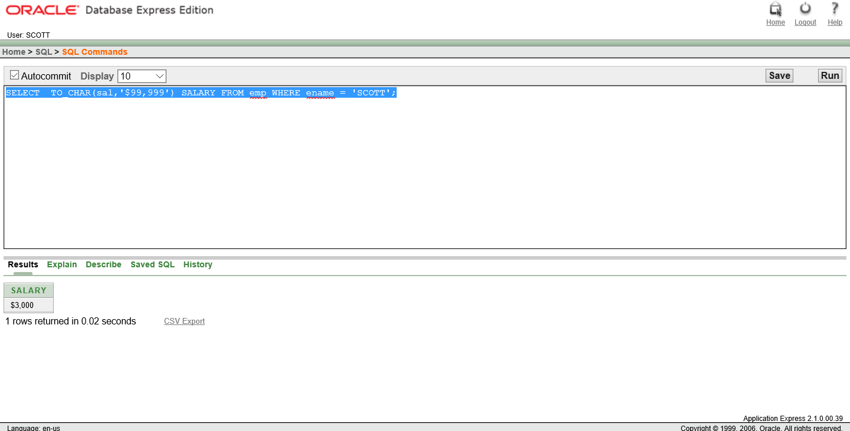

26. SELECT ename, sal, comm, (sal*12)+NVL(comm,0) FROM emp;

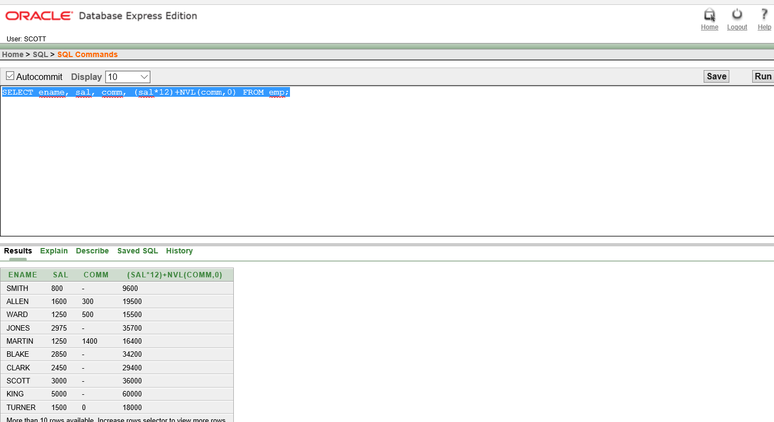

27. SELECT job, sal,DECODE(job, 'ANALYST', SAL*1.1, 'CLERK', SAL*1.15,'MANAGER', SAL*1.20,SAL)REVISED_SALARY FROM emp;

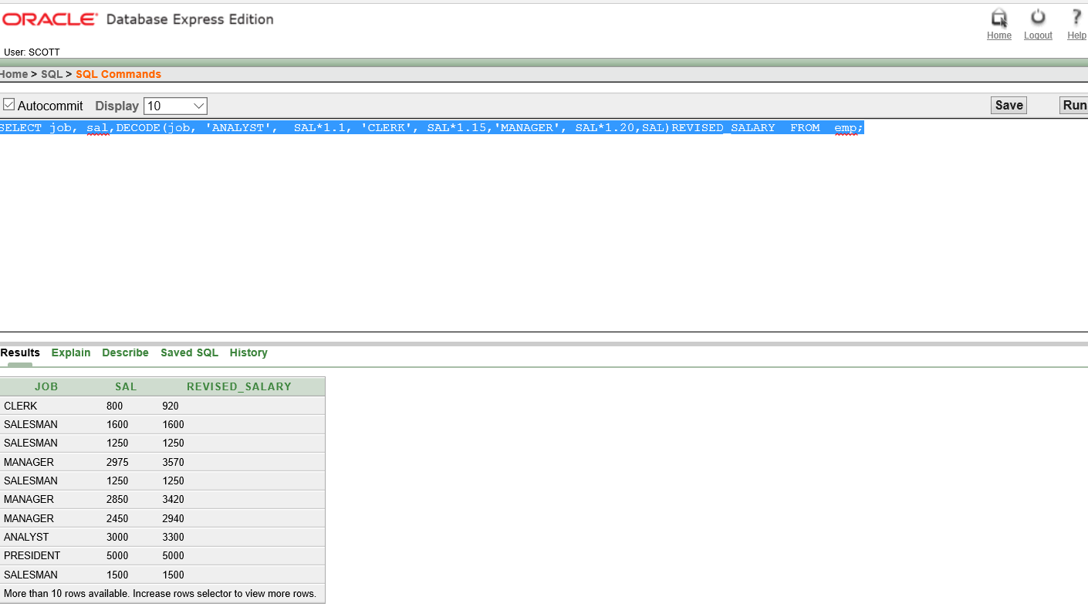

28. SELECT ename, NVL(TO_CHAR(mgr),'No Manager') FROM emp WHERE mgr IS NULL;

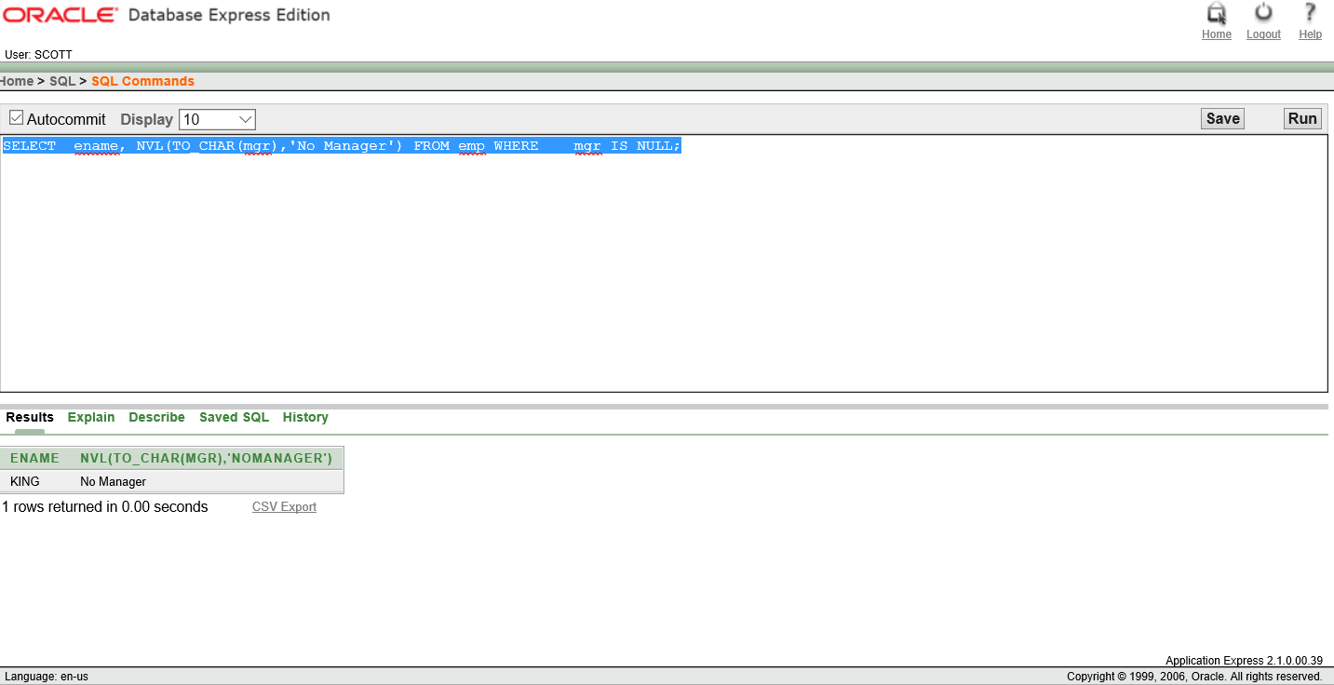

29. SELECT AVG(sal), MAX(sal),MIN(sal), SUM(sal) FROM emp WHERE job LIKE 'SALES%';

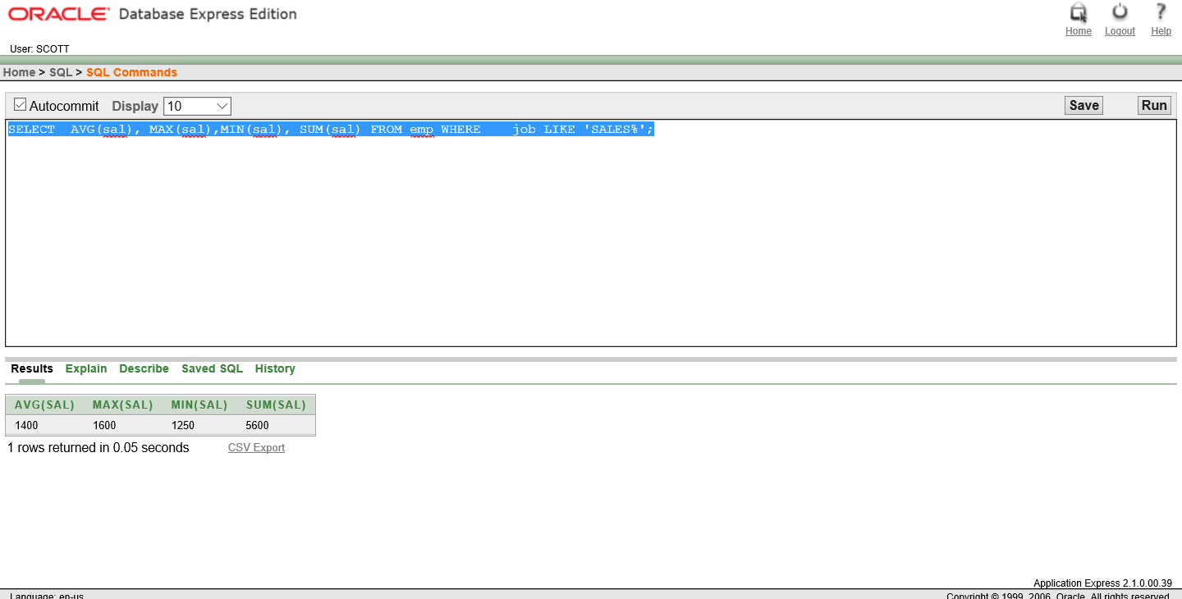

30. SELECT MIN(hiredate), MAX(hiredate)FROM emp;

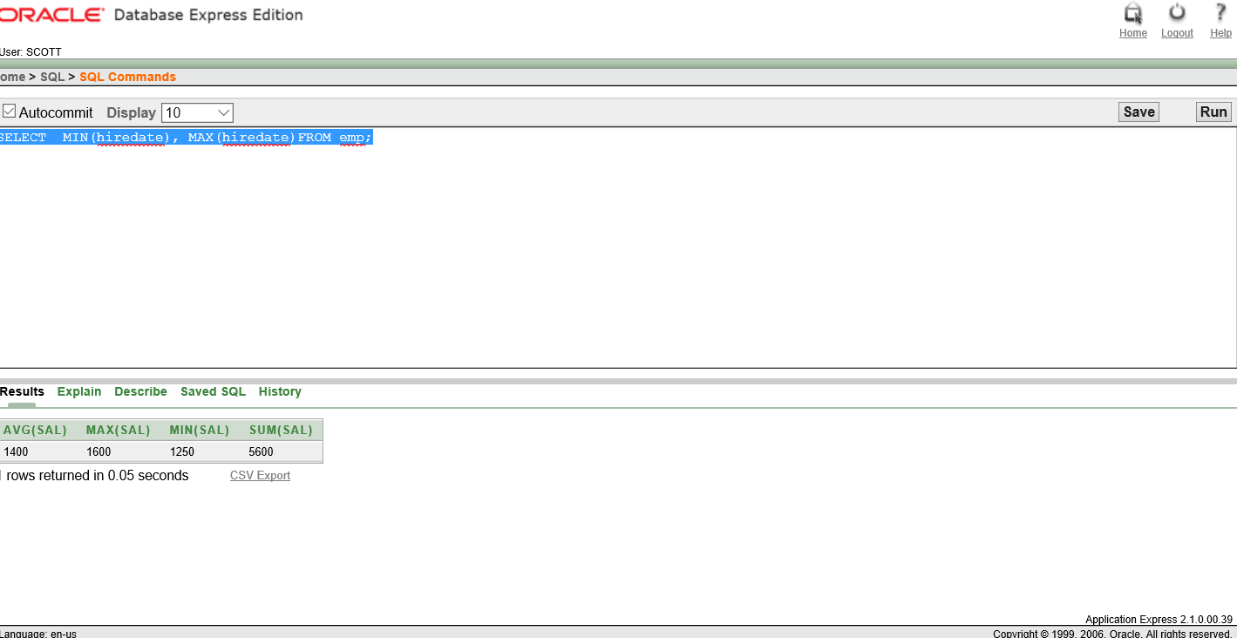

31. SELECT COUNT(*)FROM emp WHERE deptno = 30;

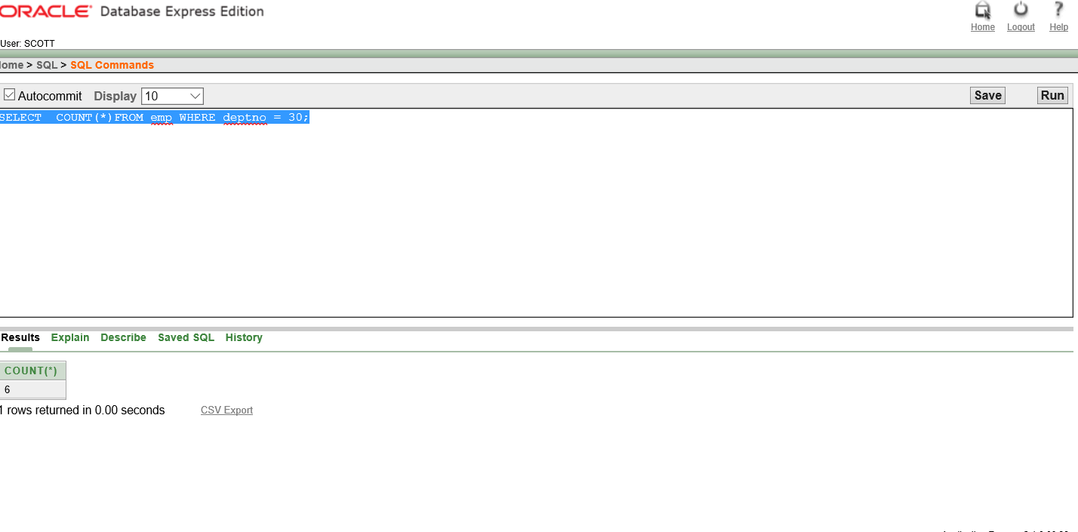

32. SELECT COUNT(comm) FROM emp WHERE deptno = 30;

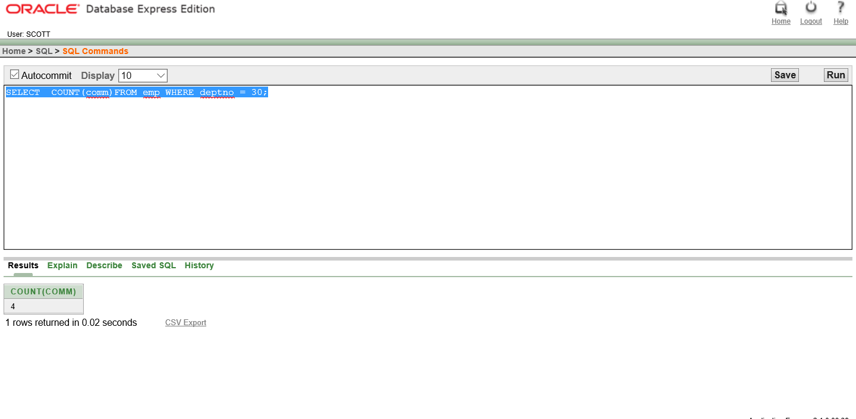

33. SELECT AVG(comm) FROM emp;

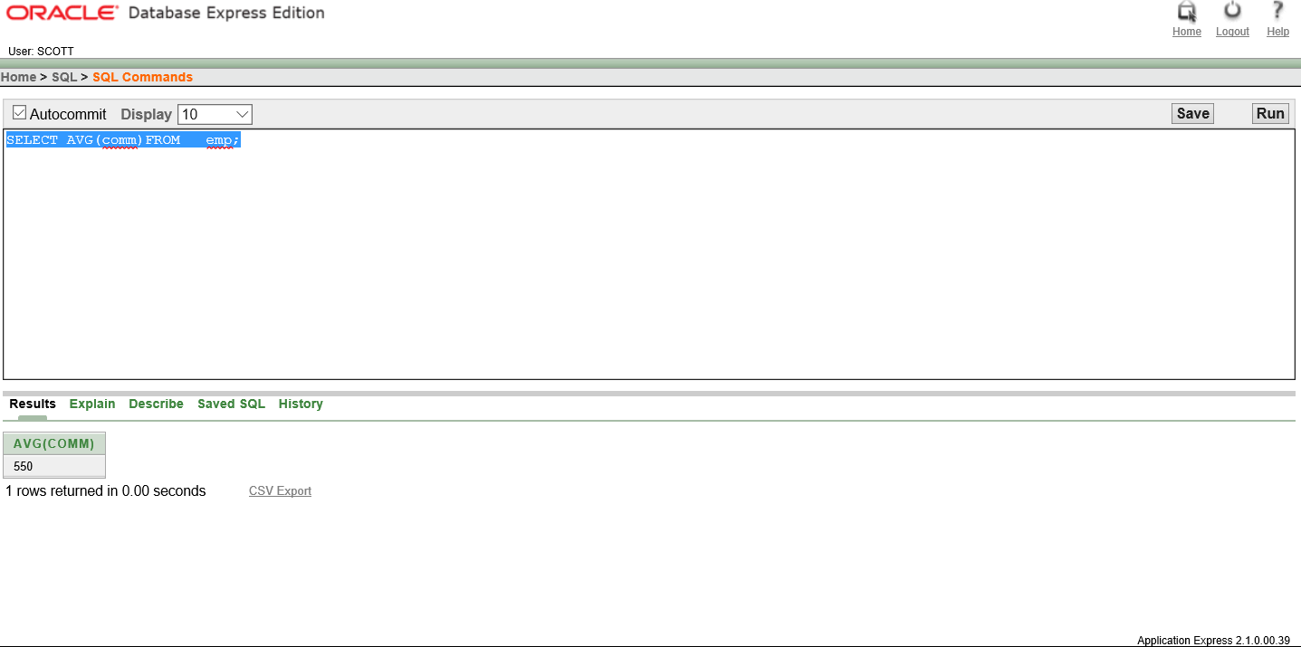

34. SELECT AVG(NVL(comm,0))FROM emp;

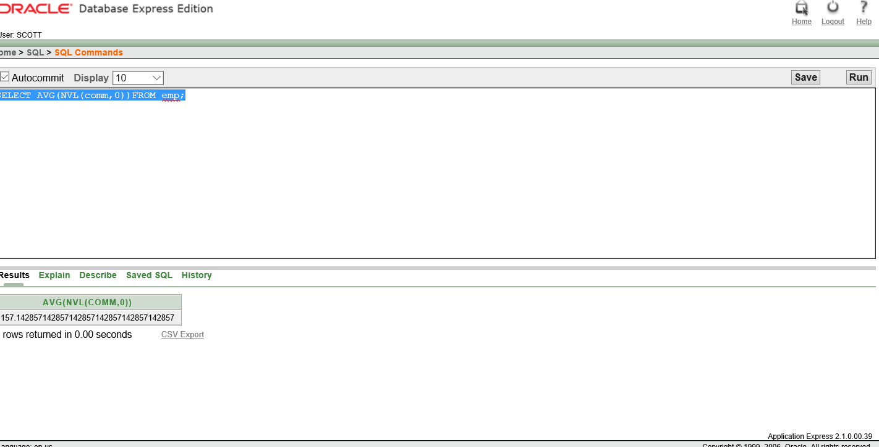

35. SELECT deptno, AVG(sal)FROM emp GROUP BY deptno;

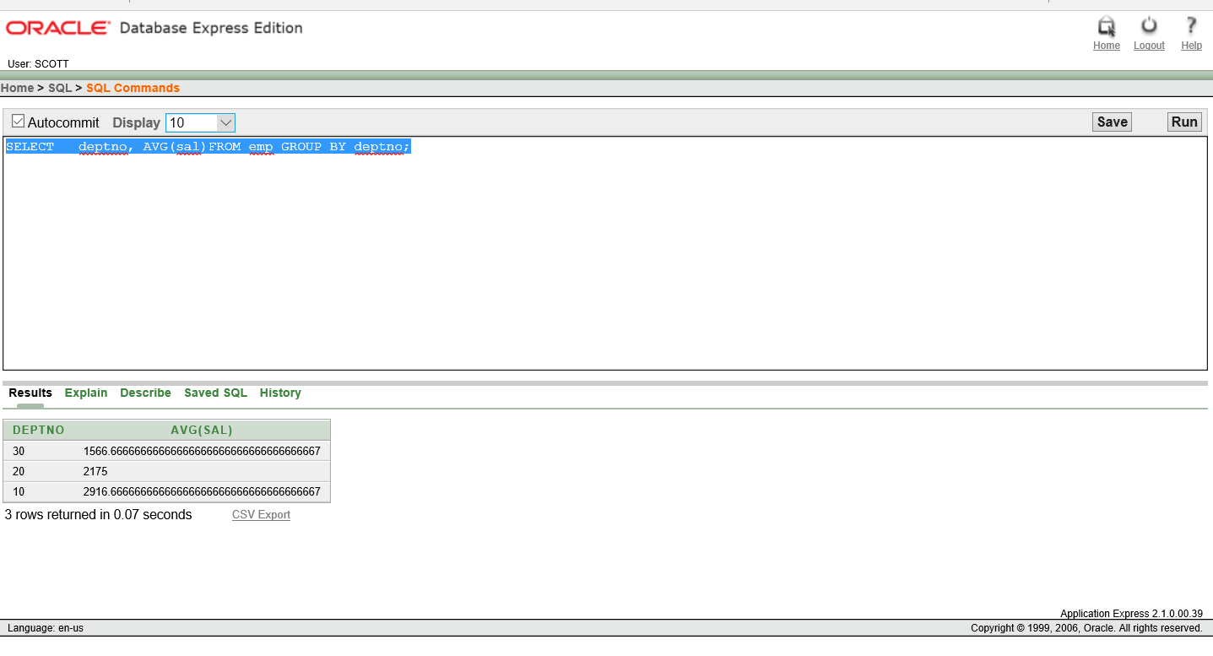

36. SELECT AVG(sal) FROM emp GROUP BY deptno;

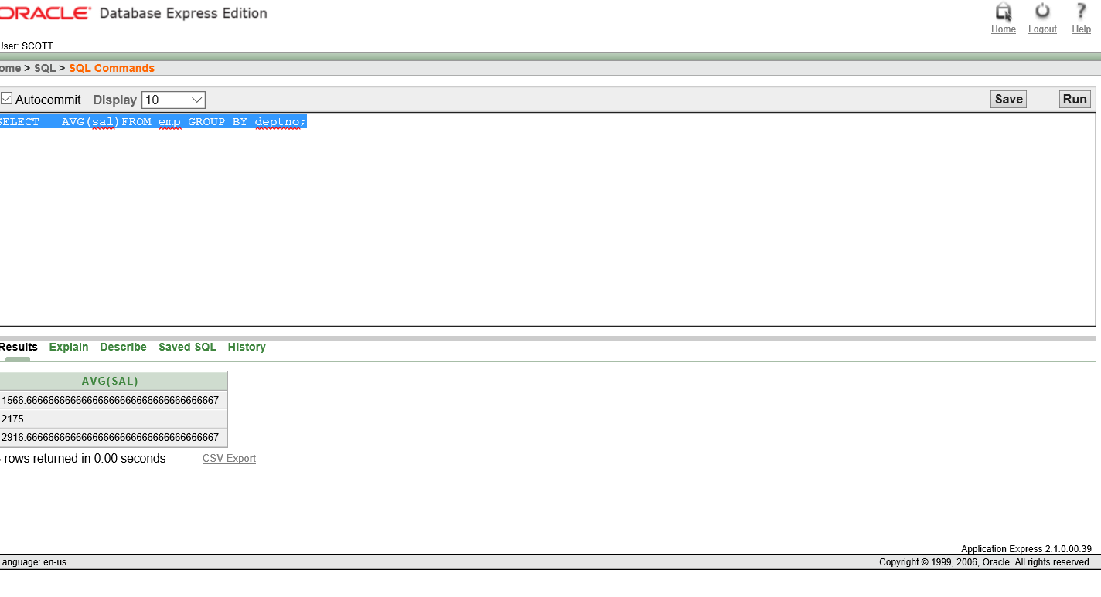

37. SELECT deptno, job, sum(sal)FROM emp GROUP BY deptno, job;

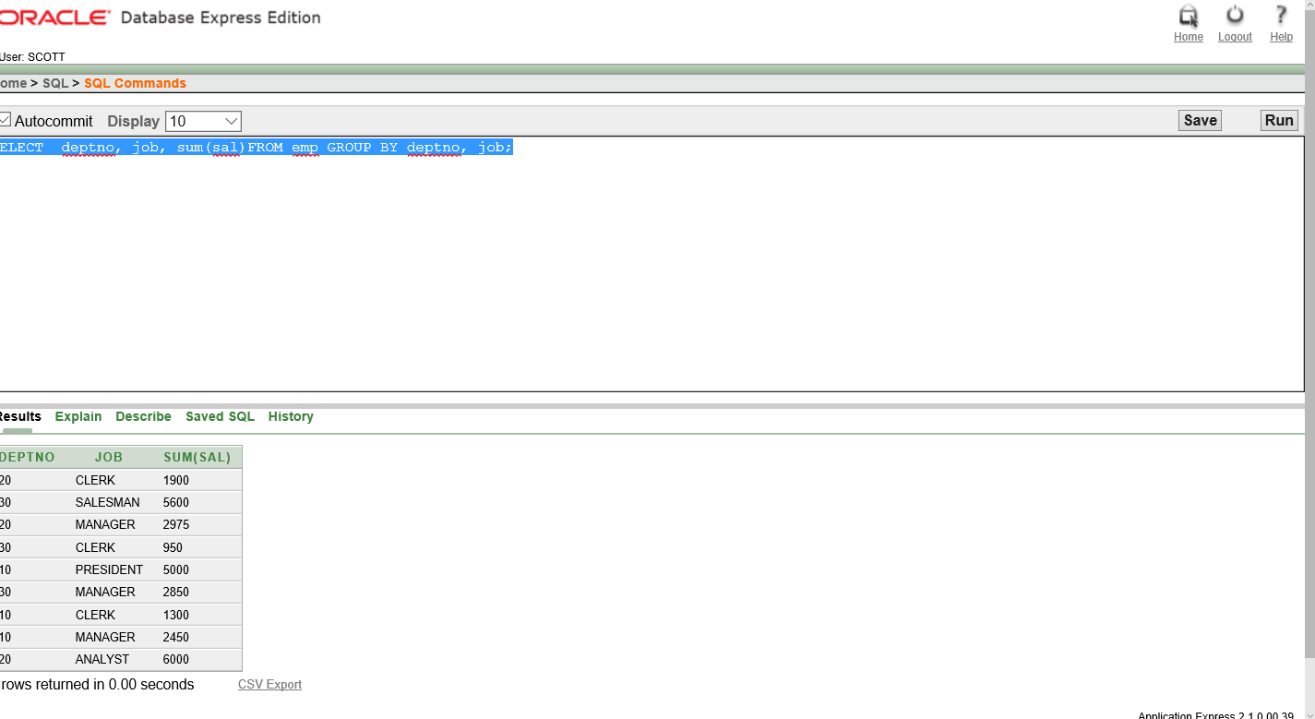

38. SELECT deptno, max(sal)FROM emp GROUP BY deptno HAVING max(sal)>2900;

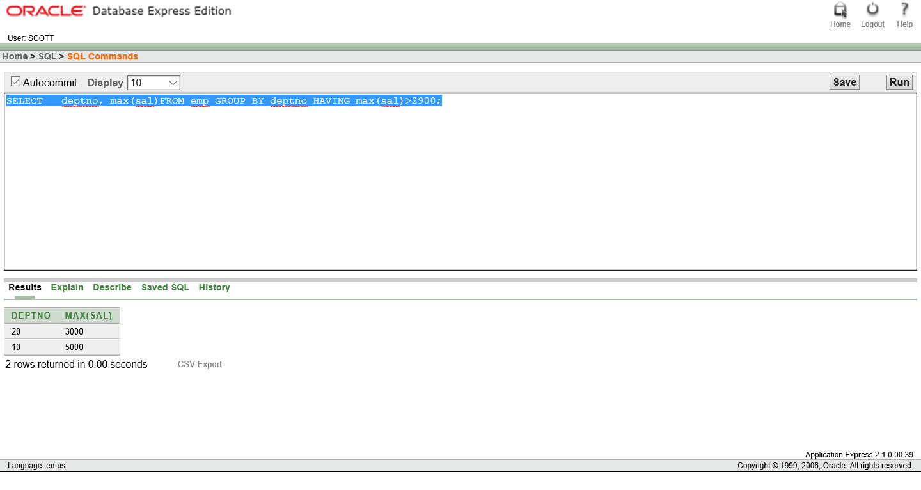

39. SELECT job, SUM(sal) PAYROLL FROM emp WHERE job NOT LIKE 'SALES%' GROUP BY job HAVING SUM(sal)>5000 ORDER BY SUM(sal);

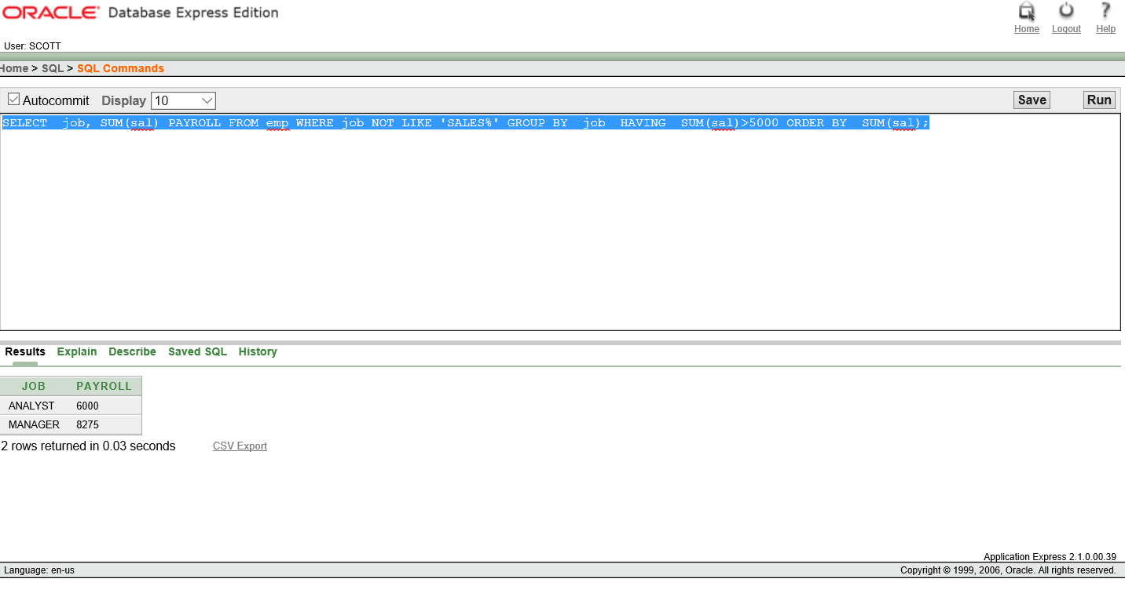

40. SELECT max(avg(sal))FROM emp GROUP BY deptno;

